

**Mathematics Methods  
YEAR 11**

**Investigation 2 – Pascal’s Triangle and Binomial Expansion**

**Semester 1 2016**

**Time allowed:** 40 minutes

**Marks Available:** 40 marks

**Materials required:** Writing implements, correction fluid/tape or eraser, ruler, Scientific calculator

**Instructions:**

1. Write your answers in the spaces provided in this Question/Answer Booklet.
2. **Show all your working clearly**. Your working should be in sufficient detail to allow your answers to be checked readily and for marks to be awarded for reasoning. Incorrect answers given without supporting reasoning cannot be allocated any marks. For any question or part question worth more than two marks, valid working or justification is required to receive full marks. If you repeat an answer to any question, ensure that you cancel the answer you do not wish to have marked.

**Part A (7 marks)**

The diagram is Pascal’s Triangle. Each number in the triangle is obtained by adding the numbers right and left above it. Rows 0 to 3 have been done. Complete the remaining rows.

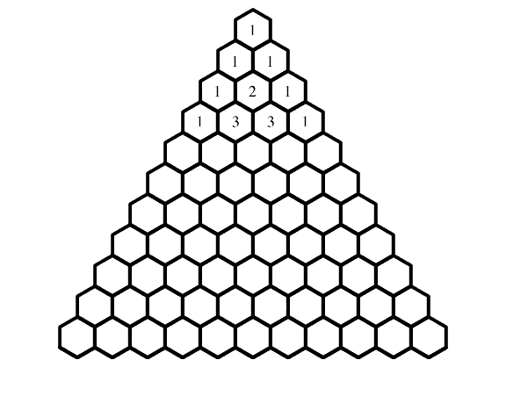

**Part B (13 marks)**

# Selections and Combinations

Imagine you have five books. Let us imagine that you wanted to read one. How many ways are there of selecting a single book? Well, that is easy, there are 5 ways. If we label the books A, B, C, D, E, we can chose any one of five; five different selections.

How many selections are there if we wanted to select **two** books? Well, let's list all the combinations:

**AB, AC, AD, AE, BC, BD, BE, CD, CE, DE.**

That makes 10 selections.

What about if we wanted **three** from five? Well, that's easy. Picking three from five is the same as **discarding** two from five so there are ten ways of doing this. Picking **four** from five is the same as discarding one from five, five ways. Of course, if you wanted to select all five books there is only one way of doing that. There is also just one way of selecting no books! So tabulating we have:

|  |  |  |  |  |  |  |
| --- | --- | --- | --- | --- | --- | --- |
| Number of selections from 5 | 0 | 1 | 2 | 3 | 4 | 5 |
| Number of ways of making selections | 1 | 5 | 10 | 10 | 5 | 1 |

Again, these numbers are a row from **Pascal's Triangle**.

The number of ways of selecting **r** objects from a total of **n** is written as **nCr**

So the above selections can be written mathematically as follows:

|  |  |
| --- | --- |
| There is one way to select no books from 5 | 5C0 = 1 |
| There are 5 ways of selecting 1 book from 5 | 5C1 = 5 |
| There are 10 ways of selecting 2 books from 5 | 5C2 = 10 |
| There are 10 ways of selecting 3 books from 5 | 5C3 = 10 |
| There are 5 ways of selecting 4 books from 5 | 5C4 = 5 |
| There is one way to select 5 books from 5 | 5C5 = 1 |

Question: "How many ways are there of selecting six objects from eight?" Mathematically, the answer is 8C6. From Pascal's Triangle, there are total of eight objects so you look at the row beginning with 1, 8, etc. You want to select six so you count along from zero, until you count six. The number there is **28**, so there are 28 selections.

Mathematically we can write 8C6 = 28. Hence, the probability of selecting 6 from 8 is

$\frac{28}{1+8+28+56+70+56+28+8+1}$ = $\frac{28}{256}$

Similarly, the probability of any boy-girl combination can also be obtained.

Exercise:

1. Using the Pascal’s Triangle,
2. for a family with three children, state the probability of
3. all boys or all girls. i.e. P(all boys) or P(all girls) = _________
4. 2 girls and 1 boy or 2 boys and 1 girl i.e. P(2G & 1B) or P(1G & 2B) = _________

State the probability of

1. Having 2 girls and 2 boys in a family of 4 children?

1. Having 2 girls and 3 boys in a family of 5 children?

1. Having a family of 8 girls?

1. Having 5 girls and a boy in a family of 6 children?

1. Having 2 girls and 5 boys in a family of 7 children?

1. Having the ninth child being a boy?

1. Having 4 girls and 4 boys in a family of 8 children?

1. Using Pascal’s Triangle, what is represented by the probability of  in row 7?
2. Mrs Emroy Harrison of Johnson, Tennessee was “Honour Mother of the Year” in 1955. She had all boys such that P(family of all boys) = $\frac{1}{8192}$. How many boys did she have?

**Part C (20 marks)**

# Algebraic Expansions

Imagine having to expand an expression like

**(1 + x)2**

As a reminder, the expression is expanded like this:

**(1 + x)2 = (1 + x)(1 + x) = 1 + 2x + x2**

In the middle pair of brackets, each term in the left bracket is multiplied by each term in the right bracket. We can do the same with a cube, i.e (1 + x)3.

**(1 + x)3 = (1 + x)(1 + x)(1 + x) = (1 + x)(1 + 2x + x2)**

**= 1 + 3x + 3x2 + x3**

If you look at the **coefficients** (the numbers on their own and in front of the x's) of the results you will see that for the first one they are 1, 2, 1 and for the second one they are 1, 3, 3, 1. These, of course, are the lines from Pascal's Triangle. And yes, it does work for all positive whole number values of the index. Prove to yourself by algebra that,

**(1 + x)4 = 1 + 4x + 6x2 + 4x3 + x4**

In fact there is a general rule that

**(a + b)4 = a4 + 4a3b + 6a2b2 + 4ab3 + b4**

As you see, the indexes begin at 4 and descend for the a's while they ascend to 4 for the b's. The coefficients are the 1, 4, 6, 4, 1 from Pascal's triangle. So let's try an example.

Expand (2 + 3x)5.

Applying the general rule of ascending and descending indexes and the coefficients from Pascal we can immediately expand the above equation (if we set *a* to 2 and *b* to 3x):

**25 + 5(24)(3x) + 10(23)(3x)2 + 10(22)(3x)3 + 5(2)(3x)4 + (3x)5**

This simplifies to

**32 + 240x + 720x2 + 1080x3 + 810x4 + 243x5**

Exercise:

Using the Pascal’s Triangle, simplify the following binomials showing all working steps:

1. ${\left(x+3\right)}^{4}$ (2)
2. ${\left(x-1\right)}^{6}$ (2)
3. ${\left(2-x\right)}^{5}$ (2)
4. ${\left(2x-y\right)}^{3}$ (2)
5. ${\left(1+xy\right)}^{7}$ (2)

6 (a) What is the coefficient of $x^{4}y^{6}$ in the expansion ${\left(x+y\right)}^{10}$? (1)

(b) Which other term has the same coefficient as $x^{4}y^{6}$? (1)

7 Write down each of the following:

(a) the third term of ${\left(x+y\right)}^{11}$? (2)

(b) the fifth term of ${\left(x-y\right)}^{7}$? (2)

(c) the 6th term of ${\left(x-1\right)}^{9}$? (2)

(d) the 4th term of ${\left(x-\frac{1}{x}\right)}^{10}$? (2)

**End of Investigation**